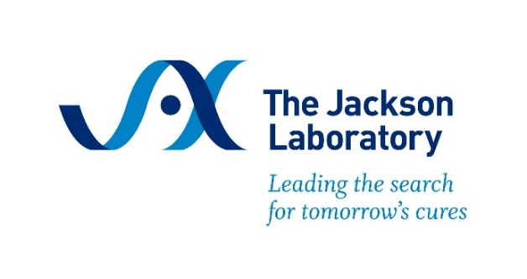

Workshop on Stereotaxic Surgery in the Laboratory Mouse
August 19-23, 2024, Bar Harbor, ME
Schedule subject to change

Monday, August 19, 2024
4:00 – 5:30 pm Registration & Welcome Reception (Highseas 1st floor)
Participants are not permitted to enter Highseas prior to 4:00pm

6:00 – 7:00 pm Dinner (Highseas 1st floor)

Tuesday, August 20, 2024
7:30 – 8:15 am Breakfast (Highseas 1st Floor)
8:15 – 8:30 am Shuttle from Highseas to GRB Training Lab
8:30 – 8:45 am Welcome & Introductions
Jennifer Corrigan, M.S., The Jackson Laboratory
8:45 – 9:45 am Survival Surgery Standards
The Jackson Laboratory
9:45 – 10:45 am Biomethods
Restraint, IP Injection and Subcutaneous injection, JAX Trainers, The Jackson Laboratory
10:45 am – 12:00 pm Introduction to Stereotaxic Instruments, Injector and Drill and other Critical Accessories and Introduction to Work Station Stereotaxic Instruments, Stereotaxic Injector & Important Accessories (Drill, Light, Magnification and Warmer)
Richard Mills, Ph.D., Stoelting, Leanne Miceli, A.S. and Jennifer Corrigan, M.S., The Jackson Laboratory
12:00 – 1:00 pm Lunch (Roscoe’s)
1:00 – 1:30 pm How to Use a Vernier Scale & Mouse Brain Atlas
Richard Mills, Ph.D., Stoelting
1:30—2:00 pm Fundamentals of Positioning Mice in the Stereotaxic Instrument (Placement in Snout Clamp and Ear Bars) Leanne Miceli, A.S. and Jennifer Corrigan, M.S., The Jackson Laboratory, Richard Mills, Ph.D., Stoelting

2:00 – 4:30 pm Intracranial Injection and Lateral Ventricle Target Validation (Identifying Bregma, Intracranial Drilling and Microinjection)
Leanne Miceli, A.S. and Jennifer Corrigan, M.S., The Jackson Laboratory, Richard Mills, Ph.D., Stoelting
4:30 pm Shuttle from GRB Training Lab to Highseas
6:00 pm Lobster Dinner (Highseas 1st Floor)

Wednesday, August 21, 2024
7:30 – 8:15 am Breakfast (Highseas 1st Floor)
8:15 – 8:30 am Shuttle from Highseas to GRB Training Lab
8:30 – 11:45 am ICVC – Brain Cannulation in Lateral Ventricle (Cannula Types, Securing Cannulas & Wound Closure) Leanne Miceli, A.S. and Jennifer
Corrigan, M.S., The Jackson Laboratory and Richard Mills, Ph.D., Stoelting

11:45 am – 12:45 pm Lunch (Roscoe’s)
12:45 – 4:15 pm Bi-Lateral Brain Cannulation (Cannula Types, Securing Cannulas and Wound
Closure) Leanne Miceli, A.S. and Jennifer Corrigan,
M.S., The Jackson Laboratory and Richard Mills, Ph.D., Stoelting
4:15 pm Shuttle from GRB Training Lab to Highseas
6:00 pm Dinner (Highseas 1st Floor)

Thursday, August 22, 2024
7:30 – 8:15 am Breakfast (Highseas 1st Floor)
8:15 – 8:30 am Shuttle from Highseas to GRB Training Lab
8:30 – 10:30 am Cerebral Spinal Fluid (CSF) Collection Leanne Miceli, A.S. and Jennifer Corrigan, M.S., The Jackson Laboratory and Richard Mills, Ph.D., Stoelting
10:30 – 11:45 am Practice and extra time for questions
Leanne Miceli, A.S. and Jennifer Corrigan, M.S., The Jackson Laboratory and Richard Mills, Ph.D., Stoelting
11:45 am – 12:00 pm Shuttle from GRB Training Lab to Highseas
12:00 – 1:00 pm Lunch (Highseas 1st Floor)
1:00 – 6:00 pm Free time
6:00 pm Dinner (Highseas 1st Floor)

Friday August 23, 2024
7:00 – 9:00 am To-Go Breakfast

9:00 am Highseas Check Out
Participants may remain on the 1st floor until 12:00 pm if needed

